Lab 08 – Windows Services

Lab 08 – Windows Services 1
Documentation: File and Storage Services 2
1. Introduction 2
2. Distributed File System (DFS) 2
2.1 Definition 2
2.2 Components 2
2.3 Advantages 2
2.4 Typical Use Cases 2
3. Work Folders 3
3.1 Definition 3
3.2 How It Works 3
3.3 Advantages 3
3.4 Typical Use Cases 3
4. Conclusion 3
Demonstration: Distributed File System (DFS) 4
Purpose of the Demonstration 4
Demonstration Contents 4
1. Overview of the Environment 4
2. Creating domain Server 4
Creating a DFS Namespace 5
4. Add 5
Teil 2: Create DFS-Namespace 8
1. By using the DFS Management console, a central share path is created, for example \\firma.local\Daten. 8
2. Right-click on Namespaces and select New Namespace. 9
3. Select the server on which the DFS namespace will be hosted. 9
Part 3: Adding Folders to the Namespace 9
1. Open your DFS namespace in DFS Management. 9
2. Right-click the namespace and select New Folder. 9
3. Assign a name to the folder (for example: "Projects"). 9
4. Click Add Folder Target. 9
5. Select a real shared folder (for example: \\Server1\Projects$). 10
Part 4: Configuring DFS Replication 11
Part 5: Client Configuration and Access 13
Prerequisites 13
Connecting the Client to the DFS Namespace 14
1. Open File Explorer. 14
2. Right-click on This PC. 14
3. Select Map network drive. 14
4. Choose a drive letter (for example: Z:). 14
5. Enter the DFS namespace path in the Folder field: 14
6. Enable Reconnect at sign-in. 14
7. Click Finish to establish the connection. 14

Documentation: File and Storage Services

1. Introduction
File and Storage Services are a core component of Windows Server, enabling the organization, management, and provision of files and storage resources within a network. They provide mechanisms to efficiently store, share, replicate, and synchronize data.
Key functionalities include:
- File sharing
- Storage management
- DFS (Distributed File System)
- Work Folders

2. Distributed File System (DFS)

2.1 Definition
DFS is a service that allows file shares across multiple servers to be unified into a single logical namespace. Users see a consistent path, regardless of which server actually stores the data.

2.2 Components
DFS Namespace:
- Organizes shares into a hierarchical folder structure.
- Users access files through a single path (e.g., \\Company\SharedData).
- DFS Replication (DFS-R):
- Replicates data between multiple servers.
- Synchronization occurs over the network with an efficient delta-transfer mechanism.

2.3 Advantages
- Simplified user access through a central namespace.
- Redundancy and high availability via replication.
- Load distribution across multiple servers.

2.4 Typical Use Cases
- Large companies with multiple locations.

- Redundant file shares for critical data.

- Synchronization of project files across departments.

3. Work Folders

3.1 Definition
Work Folders allow employees to store personal work files on corporate servers and automatically synchronize them with their Windows devices.

3.2 How It Works
- Users save files in a local Work Folder.
- Changes are automatically replicated to the central server.
- Devices can work offline; changes synchronize when the device reconnects.

3.3 Advantages
- Supports Bring Your Own Device (BYOD) scenarios.
- Automatic backup and centralized management of work files.
- Security through centralized policies and encryption.

3.4 Typical Use Cases
- Remote work or mobile workplaces.
- Synchronization of project data across multiple devices.

4. Conclusion
Windows Server File and Storage Services provide powerful tools for centralized file management while ensuring user convenience and data security.

- DFS is ideal for structured, central file shares across locations.

- Work Folders allow individual work files to be securely stored and synchronized across devices.

Demonstration: Distributed File System (DFS)

Purpose of the Demonstration
In this live demonstration, We will showcase how the Distributed File System (DFS) works in Windows Server and how it can be implemented in an enterprise environment. The goal is to demonstrate the use of DFS Namespaces and DFS Replication to create a centralized, highly available file structure.

Demonstration Contents

Overview of the Environment
  - Windows Server systems
  - Preconfigured file shares
  - Active Directory environment

Creating domain Server
  - Rename Server “Server1”
  - Restart Server
  - Ethernet Setting > Change adapter options > Ethernet > Properties > IPv4 > “Use the following ip address”
  - IP address 192.168.10.101
  - Subnet Mask 255.255.255.0
  - DNS 127.0.0.1
  - Open Server Manager
  - Tools > Add Roles and Features
  - Next > Next > Next > Server Roles : check box at “Active Directory Domain Services”
  - check box at: DNS Server > Add Feature > Next > Next > Next > Next > Next > Install
  - Open “Aktive directory domain services configuration Wizard“
  - Klick “New Forest”
  - Enter Domain example : “lme.lu”
  - Add Password ******** > Next > Next > Next > Next > Next > Install
  - restart

Creating a DFS Namespace
- Open Server Manager.
- Go to “Roles and Features”.
- Click Next until you reach the Server Roles selection.
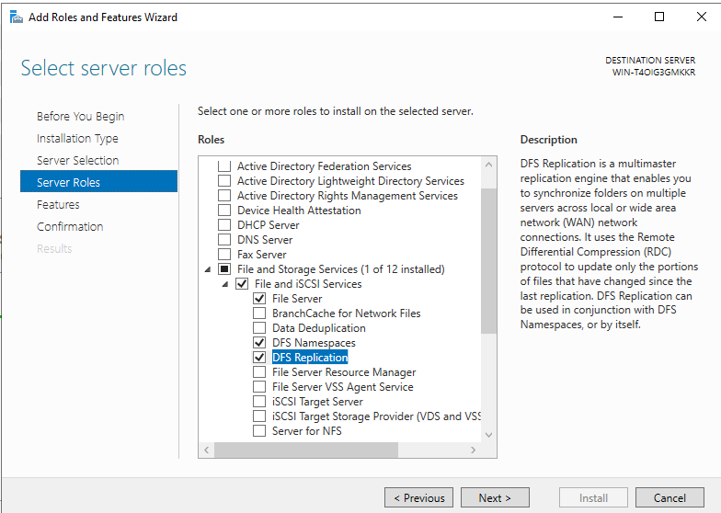

Add
- File and Storgae Services
- File and ISCSI Services
- DFS Namespaces
- DFS Replication
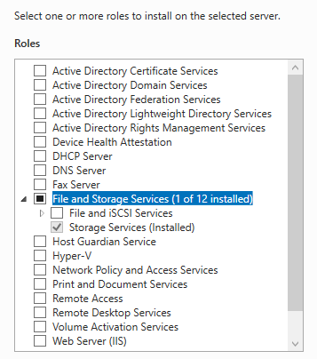
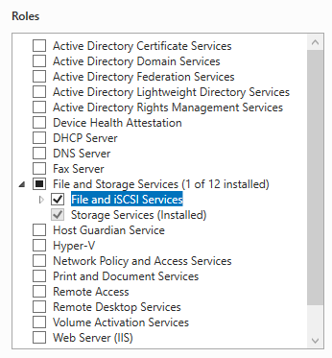
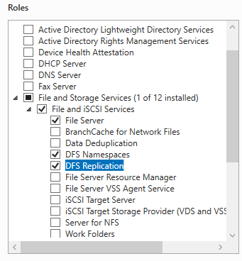

Click Install to complete the installation.

Teil 2: Create DFS-Namespace

By using the DFS Management console, a central share path is created, for example \\firma.local\Daten.
  - The console can be accessed via Server Manager → Tools → DFS Management.
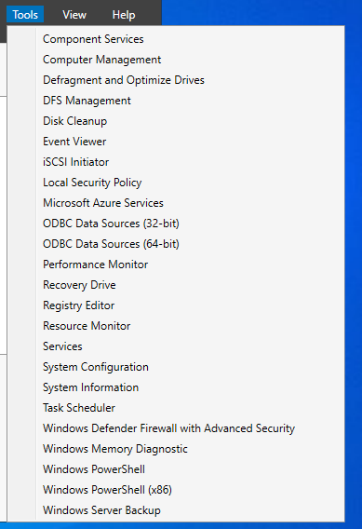

Right-click on Namespaces and select New Namespace.
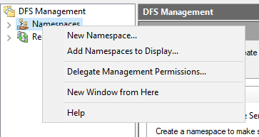

Select the server on which the DFS namespace will be hosted.
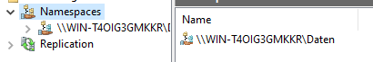
- Enter a name for the namespace (for example: Daten).
- Select the namespace type:
  - Domain-based namespace (recommended).
- Create the namespace.
After the namespace has been created, the following path is available, for example:
\\firma.local\Daten

Part 3: Adding Folders to the Namespace

Open your DFS namespace in DFS Management.

Right-click the namespace and select New Folder.

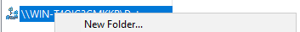

Assign a name to the folder (for example: "Projects").

Click Add Folder Target.

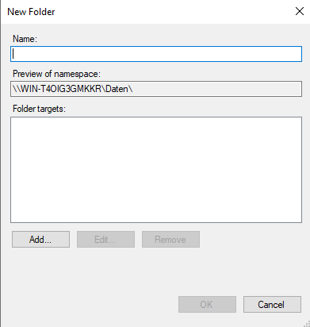

Select a real shared folder (for example: \\Server1\Projects$).
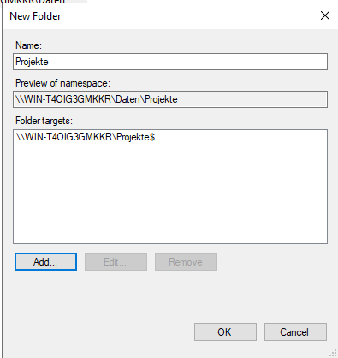
Important: The folder target must be an existing NTFS share.

Part 4: Configuring DFS Replication
This will automatically synchronize data between servers.
Create a replication group:
- DFS Management → Replication
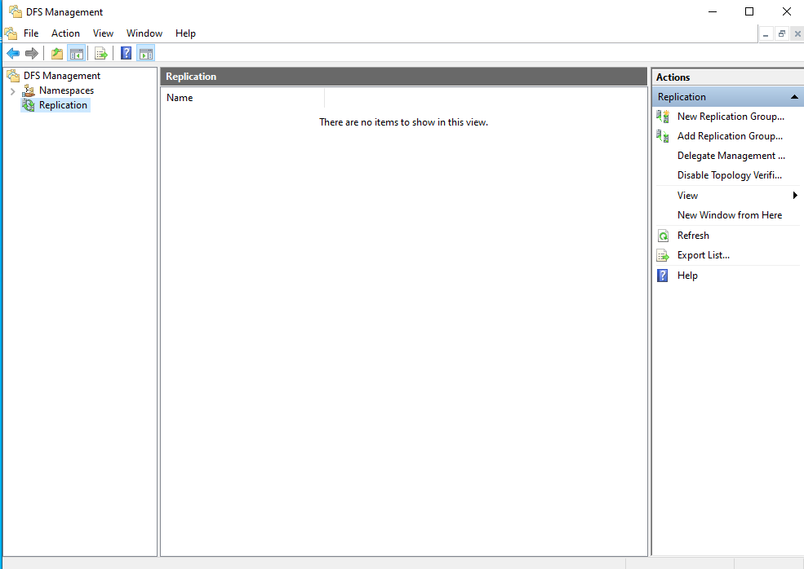
Right-click and select New Replication Group.
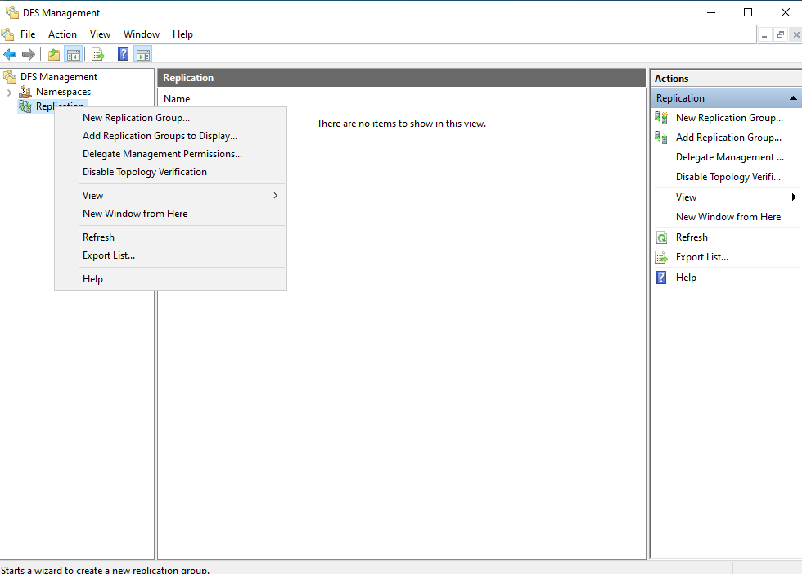
Select the replication type:
- Multipurpose replication group (Multiple Master – default)

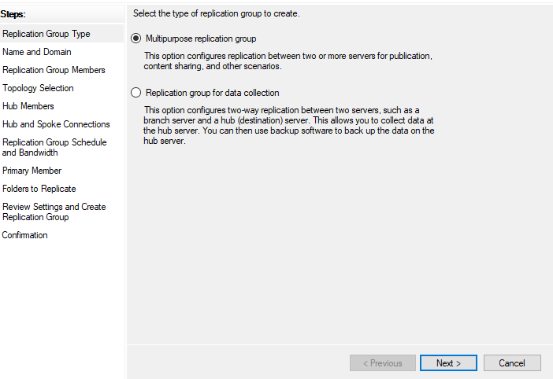
Enter a name for the replication group and specify the domain.
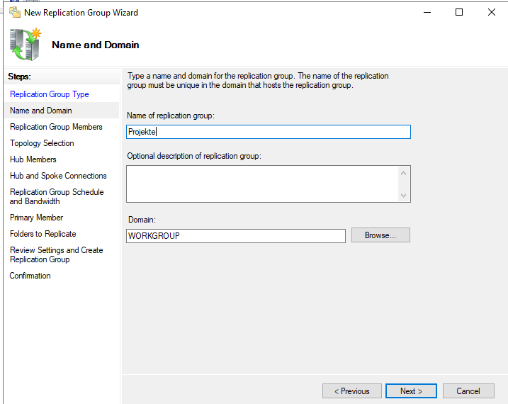
- Add the servers (for example: Server1, Server2).
- Select the primary server.
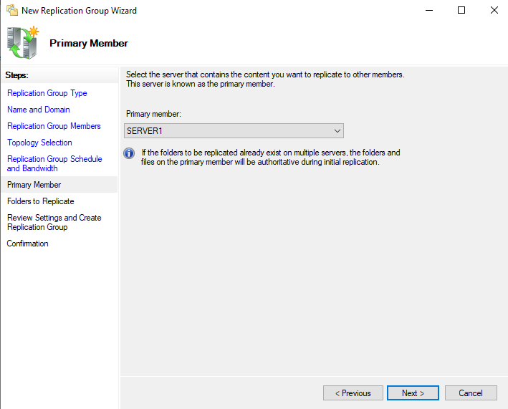
- Specify the folder to be replicated.
- Specify the target folder on each server (for example: D:\Data).
- Configure the replication schedule and bandwidth (default: Always / Full bandwidth).
Note: DFS may take a few minutes before replication starts.

Part 5: Client Configuration and Access

Prerequisites
Before a client can access the Distributed File System (DFS), the following requirements must be met:
- DFS has been correctly configured on the servers.
- A DFS namespace exists (for example: \\firma.local\Daten).
- Folder targets are configured and point to both file servers.
- The client computer is a member of the same Active Directory domain.
- Appropriate permissions are configured:
  - NTFS permissions on the target folders
  - Share permissions on the file shares
- DNS name resolution is functioning correctly (the client can resolve the domain and file servers).

Connecting the Client to the DFS Namespace

Open File Explorer.

Right-click on This PC.

Select Map network drive.

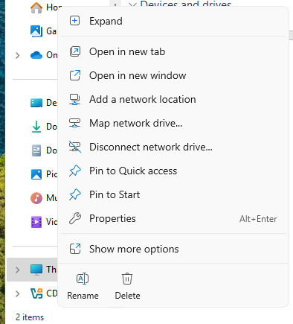

Choose a drive letter (for example: Z:).

Enter the DFS namespace path in the Folder field:
\\firma.local\Daten

Enable Reconnect at sign-in.

Click Finish to establish the connection.

